ACADEMIC YEAR 2021-2022



**JET’S ZULAL BHILAJIRAO PATIL COLLEGE, DHULE**

**PROJECT REPORT ON**

**“TRAINING & PLACEMENT CELL”**

FOR

JAI HIND EDUCATION TRUST

**GUIDED** **BY**

**SUBMITTED BY**

**Ms. Patil Kamini Bansilal**

**(BCA)**

**SUBMITTED TO**

**KAVAYITRI BAHINABAI CHOUDHARI**

**NORTH MAHARASHTRA UNIVERSITY, JALGAON**

**For partial fulfillment of the degree of**

**Bachelor of Computer Application**

Jai Hind Educational Trust’s

**JET’S ZULAL BHILAJIRAO PATIL COLLEGE**

**Deopur, Dhule.424002**

**

CERTIFICATE

This to certify that the project titled “**TRAINING & PLACEMENT CELL”** Developed at **Jet’s Zhulal Bhilajirao Patil College, Dhule.** In partial fulfillment of award of the degree **Bachelor of Computer Application** in Original work carried out under my guidance & to the best of my knowledge & belief has not been submitted by elsewhere before.

**(Guided by) (Head of Department)**

**External Examiner 1 External Examiner 2**

ACKNOWLEDGEMENT

I would like to take this opportunity to express my gratitude towards all those peoples who have in various ways helped in successful completion of present this project.

In the completion of this work, the principal, guide for his timely kind co-operation and providing required facilities.

My special acknowledgement to guide for his timely suggestion, help and encouragement. I must pay my most sincere indebtedness towards all staff members without whose help, this project would have been much more difficult to complete.

I am also thankful to my friends. My sincere thanks also goes to those who have directly or indirectly helped me in this project.

I would also like to pay humble gratitude to my parents for providing Emotional encouragement and moral support for this project.

Ms. Patil Kamini Bansilal

Organization CERTIFICATE

Thisis certify that Miss Patil Kamini Bansilal student for TYBCA JET’s Zhulal Bhilajirao Patil College of Commerce & Management, Dhule, has done this project on

**“TRAINING & PLACEMENT CELL “**

For

**“JAI HIND EDUCATION TRUST”**

This Project is implemented at our organization and helpful to us our daily transaction. We found him since, punctual and hardworking during completion of this project work. We wish her bright and successful future.

**Date**: -  **Seal and Stamp**

**Place: - Dhule**

**INDEX**

|  |  |  |
| --- | --- | --- |
| **Chapter** | **Name** | **Page no** |
| 1 | Introduction | 7 |
| 2 | Abstract | 8 |
| 3  3.1  3.2 | Nomenclature  Need of computerization  Advantages of computerization system | 10 |
| 4  4.1  4.2  4.3  4.4  4.5 | Hardware & software Requirements  Hardware  Software  Prior Project Development  Record Review  Observation | 12 |
| 5  5.1  5.2  5.3  5.4  5.5 | System Development Life Cycle  Problem identification  Feasibility Study  System Requirement Analysis  System Design Specification & Programming  Evolution of the system | 20 |
| 6  6.1 | Feasibility Study  Objective of Study | 28 |
| 7  7.1 | System flowcharts  System design diagram | 29 |
| 8  8.1  8.2  8.3  8.4 | Data Flow Diagram & E-R Diagram  Zero Level  First Level  Second Level  E-R Diagram |  |
| 9 | Data dictionary | 32 |
| 10  10.1  10.2 | Sample input & output  Sample input designs  Sample output designs | 38 |
| 11  11.1  11.2  11.3  11.4 | Testing & debugging  Testing  Debugging  Outcomes  Test cases | 49 |
| 12 | Implementation | 52 |
| 13 | Merits & Demerits , Advantages  Existing System & its Demerits  Existing System & its Merits  Advantage of Proposed System  Project Models | 55 |

**CHAPTER 1**

**INTRODUCTION:-**

**“Training & Placement Analysis”**

Training and Placement Cell is a total management and informative system, which provides the up-to date information of all the students in a particular college. TPC helps the colleges to overcome the difficulty in keeping records of hundreds and thousands of students and searching for a student eligible for recruitment criteria from the whole thing. It helps in effective and timely utilization of the hardware and the software resources.

The home page contain various links such as links to login, various services like Events happened, achievements and recruiter details etc., The administrator will create the users and the users will use the accounts created by administrator. When the user enters into his respective page he can update his details, and the details are to be approved by the administrator.

All the users have some common services like changing password, updating details, searching for details, checking the details, mailing to administrator, and reading the material uploaded by admin if the user is a student. Administrator has the services to add events and achievements and he can reply to the mails sent by users.

**CHAPTER 2**

**ABSTRACT:-**

Training and Placement Cell is a web based application developed in the windows platform for the training and placement department of the college in order to provide the details of its students in a database for the companies to their process of recruitment provided with a proper login.

The Training and Placement Cell contains all the information about the students. The system stores all the personal information of the students, like their personal details, their aggregate marks, their skill set and their technical skills that are required in the CV to be sent to a company.

The system is an online application that can be accessed throughout the organization and outside as well with proper login provided. This system can be used as an application for the TPO of the college to manage the student information with regards to placement.

 This project contains all the details of the students that can be viewed by all the users (read only), but can be modified only by the student with an authorized service. By maintaining student’s information, the system helps to have selections to be made easy for a company in its test for the recruitment process. The students can update their own information only.

Students can search for the material required for the selection process such as aptitude, reasoning…etc. and various websites for placement papers. Events happening in the college and the achievements of the student’s i.e. selected students’ details can be viewed by all the users.

So, our project provides a facility of maintaining the details of the students, and gets the requested list of candidates for the companies who would like to recruit the people based on a given query.

**CHAPTER 3**

**NOMENCLATURE:-**

Computer, the machine prefers accuracy and speed .It has developed a considerable impact on many aspects of our day to day life. There are innumerable fields where computer is playing already playing a key role. There is a vast increase in the range of computer application corresponding to increase on the effect the computer will have on our daily lives.

Now a day, database system is becoming important and wide spread. In all organization it plays an important role in human life and is relatively considered as basic need. Computerization comes into picture when number of transactions increases as a result of increase in number of organizations. The automation or computerizations is to keep up-to-date information of all system areas/keys. Database allows more quick and accurate reports.

The present system is user friendly, easy to use and it is hoped that it provides a layman the joy of working on a computer and gives an edge of speed ,accuracy, efficiency in disposal of tasks as compared to laborious manual work.

**Need of Computerization:-**

* In order to bring down the available down time to zero and to reduce the available down time particularly management should get machine utilization.
* A down time breaks up reports with high accuracy and well within the time and for this the application of computer is essential.
* Computer can turn out huge amount of complicated work several thousand of time faster than a human being.
* Huge capacity of work very high speed and absolute reliability are the three qualities that have made the computer the right vehicle to bring home the harvest of science and technology.
* It becomes easy to maintain the inventory by computer to keep track of amounts to and from customer and transactions.

**Advantage of Computerized System:-**

* With the computer work can speed up alternative tries to and an optimum solution can be avoided within the target time.
* Computer is helpful in many practical situations to obtain the best solution instead of solution obtained with efforts.
* Huge amount of data can be stored which helps for periodical results and periodical review.

**CHAPTER 4**

**HARDWARE AND SOFTWARE REQUIREMENTS**

**Hardware:**

IBM PC or compatible with PIII 7000 processor 128 MB RAM, 10.2 GB Hard Disk. The office automation runtime versions are as follows.

* IBM PC compatible with PIII 7000 processor
* Celeron or higher processor
* 1GB DDR 2 –RAM
* 320 GB Hard Disc
* DVD Drive Optional

**Software:**

* Operating System : Windows XP or more
* Front End: Visual Studio 2008 (VB.Net)
* Back End : MS-Access

Along with this for taking printout, it is necessary to use dot matrix printer which can print line of 132 characters having facility condensed, double strikes etc.

The configuration given above is the standard configuration. CPU with 8088 any other upward can be used with at least minimum 640 KB RAM, 20 MB of DD and 360 KB of SDD with mono or VGA display are also applicable to use proposed system.

**INTRODUCTION TO PHP.NET 2008**

**Technology Used**

*Front-end: PHP*

* **Introduction PHP**
* **What is PHP?**
* PHP is an acronym for "PHP: Hypertext Preprocessor".
* PHP is a widely-used, open source scripting language.
* PHP scripts are executed on the server.
* PHP is free to download and use.
* PHP is an *embedded* scripting language when used in web pages. This means that PHP code is embedded in HTML code.
* **What Can PHP Do?**
* PHP can generate dynamic page content
* PHP can create, open, read, write, delete, and close files on the server
* PHP can collect form data
* PHP can send and receive cookies
* PHP can add, delete, modify data in your database
* PHP can be used to control user-access
* PHP can encrypt data
* **Why PHP Used?**
* PHP runs on various platforms (Windows, Linux, UNIX, Mac OS X, etc.)
* PHP is compatible with almost all servers used today (Apache, IIS, etc.)
* PHP supports a wide range of databases
* PHP is free. Download it from the official PHP resource: [www.php.net](http://www.php.net/)
* PHP is easy to learn and runs efficiently on the server side
* **Basic PHP Syntax**
* A PHP script can be placed anywhere in the document.
* A PHP script starts with <? php and ends with?>
* <? php  
  //PHP codes  
  ?>
* The default file extension for PHP files is ".php".
* A PHP file normally contains HTML tags, and some PHP scripting code.
* Below, we have an example of a simple PHP file, with a PHP script that uses a built-in PHP function "echo" to output the text "Hello World!" on a web page:
* <html>  
  <body>  
  <h1>my first PHP page</h1>  
  <? php

Echo "Hello World!";  
?>

</body>  
</html>

* **The PHP Platform was designed to provide :**
* Increased interactive capability for Web sites, enabled by greater use of XML (Extensible Markup Language) rather than HTML
* Centralized data storage, which will increase efficiency and ease of access to Information, as well as synchronization of information among users and devices
* The ability to integrate various communications media, such as e-mail, faxes, and telephones.
* New versions of Windows and Office that implement the .PHP strategy coming on the market separately. PHP is a development environment that is now available. Windows XP supports certain PHP capabilities

*Back-end: MySQL*

* **Introduction to PHP** **- MySQL Database**

With PHP, you can connect to and manipulate databases.

MySQL is the most popular database system used with PHP.

* **What is MySQL?**
* MySQL is a database system used on the web
* MySQL is a database system that runs on a server
* MySQL is ideal for both small and large applications
* MySQL is very fast, reliable, and easy to use
* MySQL uses standard SQL
* MySQL compiles on a number of platforms
* MySQL is free to download and use
* MySQL is developed, distributed, and supported by Oracle Corporation
* MySQL is named after co-founder Monty Wideness’s daughter

**PRIOR TO PROJECT DEVELOPMENT**

**PRIOR TO PROJECT DEVELOPMENT:-**

Before working on any project, it is always advisable to gather all information relevant to the system, meet the different people who work in the organization, and various aspects covering the basic requirement of development of the system, creating databases, storing vital data and extracting various forms and reports. For this purpose, following strategies is evolved.

* **INTERVIEWING:-**

This technique is used to collect information from individual or from groups. This art is refined with practice rather than following the books. This invaluable technique gathers qualitative information, opinions, policies, suggestions, underlying problems etc.

It also clearly indicates as to whether there is any resistance to the proposed system. However, there are certain points to be remembered in conducting interviews-

1. Put yourself in other man’s place and pose your question. Cultivate the ability to appreciate his points of view.
2. Let him do the most talking, listen to him patiently because listening carefully is an art.
3. Ask specific questions.
4. Notice when he does not speak in reply to a question.
5. Do not allow your mind to wander. It usually reflects on your face. When the interviewer drifts from the subject, bring him back to track tactfully.
6. Do not show you are in a hurry.
7. Distinguish between fact and opinion.
8. Always be polite.

* **QUESTIONNAIRE-**

Questionnaires may be used as a supplement to the interview. The questionnaires shall have open ended questions like what are the major and minor problems in the existing system. Questionnaires are useful for-

1. Gathering numerical data.
2. Getting relatively simple opinion from a large number of people.
3. Obtaining collective opinion etc.

**RECORD REVIEW-:**

As the saying goes, ‘believe in record than in people’. Thus sea good analyst always gets facts from documents. An existing system can be better understood by examining existing documents, forms and files. This record review can take place at the beginning of the system study for comparing actual operation. These records may include-

* + 1. Written policy manuals.
    2. Rules and regulations.
    3. Forms and documents.

The following questions may be useful in the analysis for form

* + - 1. Who uses these forms?
      2. Do they include all the necessary information?
      3. How readable and easy to follow is the form?
      4. Is it ideal for analysis?
* **OBSERVATIONS-**

Observation is very important task to collect the real information for the system analyst. It is not quantity of time spent on observation which is important. But the work content and methods are very powerful observations should look for-

* Operational effectiveness.
* Interruptions in the normal flow of work.
* The usage of files and documents.
* Informal communication etc.

On-site observation provides a close view of working of the system. But the analyst’s role should be to strictly obtain information as a detached observer.

**CHAPTER 5**

**SYSTEM DEVELOPMENT LIFE CYCLE** **(S.D.L.C.)**

The basic idea of SDLC is that there is a well-defined process by which a system is conceived, developed and implemented. SDLC recognizes the existence of a life cycle. The phases in the life cycle are described differentially different authors. We mention here a six stage SDLC which is performed in two steps, viz.

1. System Analysis, and
2. System Design.

System analysis and system design together involve six stages-

1. Problem Identification.
2. Feasibility Study and cost benefit analysis.
3. System requirements analysis.

System design involves-

1. System design specification and programming.

**System implementation and maintenance.**

1. Evaluation of the system.

**1.) PROBLEM INDENTIFICATION:-**

One of the most difficult tasks of system analysis is identifying the real problem of the existing system. Experienced analysts spend considerable time on the existing system. Experienced analysts spend considerable time on these tasks, without clear understanding of wastage of time and energy at a later stage. Hence, several questions must be proposed before identifying the correct problem at this stage itself. The questions may include-

* + - What is the actual problem?
    - What are the causes for this problem?
    - How complex it is?
    - What are the likely solutions to this problem?
    - What type of benefit can be expected once the problem is solved?

**Advantages of problem identification-**

* + - It helps in pin-pointing the problems, setting proper system goals and determining the boundaries of the project taking into consideration the limitations of the available resources.

**2.) FEASIBILITY STUDY AND COST BENEFIT ANALYSIS:-**

Feasibility study is carried out wherever a complex problem occurs. It is in fact a preliminary investigation which emphasizes the ‘look before you leap’ approach to any important project. This point is discussed at length in a separate chapter.

**3.) SYSTEM REQUIREMENT ANALYSIS:-**

Requirement analysis is the determination of the requirements for a new system. Once the system has determined that a problem exists and has obtained permission to do something about it, then the requirement analysis begins.

Requirements analysis for the new system should identify the user’s request first. This will enable the system to be more user friendly rather than designer friendly. Hence the requirement analysis will determine-

* + - What outputs are needed?
    - What inputs are needed to obtain these outputs?
    - What operations may be performed to obtain these outputs?
    - What operational and accounting controls are needed, etc.?

Different ways to access the user requirements include-

* + - Asking users directly
    - Interviews
    - Questionnaires
    - Record view (counting documents and transactions, often by sampling).
    - Developing various flowcharts.

**4.) SYSTEM DESIGN SPECIFICATION & PROGRAMMING:-**

As we move from system analysis to system design, we are in fact moving from the conceptual to the physical aspects of the life cycle i.e. we are moving from ‘what’ part to ‘how’ part. In system development, this requires great imagination with due emphasis on ground realities. Obviously this is challenging. Now the stage is set for the system to be defined in terms of its specification. These specifications are-

* Output Design
* Input Design
* Procedure
* Information Flow
* Files And Databases
* Manually Used Forms
* Programs Specification Etc.

When system design is completed, full details of developed system will be available. This stage is the second check point and the system project term must take a decision to whether implement the system or altogether stop implementing it.

**5.) IMPLEMENTATION, FOLLOW-UP & MAINTENANCE:-**

Implementation may not be a creative process but it certainly is a difficult task. This is because users have to accept the system. Hence human considerations will have to be attended to very carefully. User’s training and availability of user’s reference manuals with procedures to tackle ‘trouble shooting’ are must for this purpose. Implementation Includes-

* + Site Preparation.
  + Installation of new equipment’s
  + Users training, seminars, meetings to gain user support
  + Use of new inputs and procedures
  + Trial and parallel runs of the system on the computer

When the system maintenance becomes more costly and time consuming, new system will have to be put through thereby completing the full system life cycle.

**6.) EVALUATION OF THE SYSTEM:-**

Evaluation is nothing but a feedback to the system. This is the third and final check point of SDLC. Naturally, evaluation considers the strengths and weaknesses of the system which include-

* Operational evaluation. It includes-
  + Response time
  + Easy to use
  + Reliability of computation
  + Adequacy of storage capacity etc.
* User Management Assessment Evaluation

How often managers use the information system and how far they are satisfied judges the real worth of a system. The use of questionnaire and interview methods will be helpful in this respect. This evaluation along provides a wealth of information to enrich the system. Hence this stage should not be treated lightly.

**CHAPTER 6**

**FESIABILITY STUDY**

Feasibility study is second step in system development life cycle. A Feasibility study is test of proposal. According to the viol liability, impact to meet. User need and effective use or resources. Feasibility study involves

1. Economical Feasibility
2. Technical Feasibility
3. Behavioral Feasibility

**1. Economical Feasibility**

Economical feasibility is the most frequently used method for evaluation of effectiveness of proposed system.

* Cost benefit analysis is the most commonly used procedural for this feasibility.
* Benefits and saving are determined from proposed system and compare with cost.

**Different type of cost are considered**

* Man Power Cost
* Hardware Cost
* Operational Cost

**Man Power Cost:**

Out proposed system can be communicated with department such as stores stocks and issue so that less manpower is required to maintain system.

**Hardware Cost:**

Company has computerized network system. So hardware cost is buying and maintain oracle.

**Operation Cost:**  Commonly has sufficient man power that can operate computer vary easily, so that operating cost of proposed system is training cost of staff for learning oracle.

1. **Technical Feasibility**

In the technical feasibility a study of function, performance and constraints that may affect the ability to achieve and acceptable system are considerable. Technical feasibility centers around the existing computer system and of what extend it can support the proposed system.

In the proposed system networking is required which is already available with company and software requirement is of oracle with developer 2000, which company has to buy.

1. **Behavioral Feasibility**

Generally people are inherently resistant to change and computer has been known to feasibility change. Behavioral feasibility deals how strong a reaction. The user staff is likely to have towards development of computerized system. Is there any proper system from management for user? Have the user been involved in planning and developing proposed system.

**Alternative and trade off-**

During the feasibility study phase alternative solutions to the problem as absolution cost benefit analysis is done to choice one of the alternative as a solution. Broad solution will consist of

* Specification of the information to be made available by the user.
* Description of what will be done manually and what will be done by computer.
* Specification of new computing equipment needed.

Each System function with its requisite performs and interface characteristic is allocated to one or more system element.

**Objective of the System:-**

Following are the objectives of System

* Provides mass storage for relevant data.
* Makes data access easier for user.
* Makes the easier modification of data.
* Eliminates data redundancy.
* Allows growth in database system.
* Protects data from physical harm, unauthorized access.
* To generate reports as and when required.
* To maintain historical data.

**CHAPTER 7**

**SYSTEM FLOWCHARTS**

**SYSTEM DESIGN DIAGRAM**-:

**REPORT**

**TRANSACTION**

**MAIN MENU**

**MASTER**

Company letter

Selection

Call letter

Company Information

Trade Information

Student Information

Company Report

Trade Report

Student Report

Company letter

Report

Selection Report

Call letter Report

**CHAPTER 8**

**Data Flow Diagrams & E-R Diagrams**

**DATA FLOW DIAGRAMS-:**

**1) ZERO LEVEL:-**

**DATA INFO**

**User**

**User**

**2) FIRST LEVEL**

**Info**

**User**

**Invalid Massage**

Student

Company

Trade

Call letter

Selection

**2) SECOND LEVEL-:**

**User**

**User**

Student

Company

**User**

**User**

Trade

Seletion

**E-R DIAGRAMS**

Company

Letter

Company

cc

Student

Trade

st

Order

Inword_Master

Customer

Selection

ss

Student

**CHAPTER 9**

**DATA DICTIONARY**

The data dictionary is a catalog of all elements or attributes in the system. It is a Document that collets, ordinates and confirms what a specific data turn means to different people organization.

The data dictionary is also referred as Meta Data (Data about data) and centralized depository.

**Table: STUDENT**

|  |  |  |  |  |
| --- | --- | --- | --- | --- |
| **Field** | **Fieldname** | **Description** | **Type** | **Width** |
| 1 | Name | Name | Text | 30 |
| 2 | Prn | Permanent Registration no | Number | 20 |
| 3 | Rno | Registration no | Number | 35 |
| 4 | Tcode | Trade code | Number | Double |
| 5 | Tyear | Trade year | DateTime | - |
| 6 | Toyear | Toyear | DateTime | - |
| 7 | Tmarks | Total marks | Number | 3 |
| 8 | Outof | Out of | Number | 3 |
| 9 | Grade | Grade | Text | 15 |
| 10 | Noofcall | Number of call | Number | 5 |
| 11 | Join | Join | Date time | - |
| 12 | BDate | Birthday Date | DateTime | - |
| 13 | Ccode | Company Code | Number | 8 |
| 14 | Gender | Gender | Text | 15 |
| 15 | Caste | Caste | Text | 30 |
| 16 | Rdate | Registration Date | Date time | - |
| 17 | Call | Call | Number | Double |
| 18 | Height | Height | Number | Double |
| 19 | Weight | Weight | Number | Double |
| 20 | Spect | Spect | Text | 50 |
| 21 | Phoneno | Phone number | Number | 15 |

**TABLE: CALL_Letter**

|  |  |  |  |  |
| --- | --- | --- | --- | --- |
| **Field** | **Field Name** | **Description** | **Type** | **Width** |
| 1 | Callno | Call Number | Number | Double |
| 2 | Cdate | Call Date | DateTime | - |
| 3 | Lno | Letter number | Number | 18 |
| 4 | Ccode | Company Code | Number | Double |
| 5 | Prn | Permanent registration no | Number | Double |
| 7 | CallDate | Call Date | DateTime | - |
| 8 | Tcode | Trade code | Number | Double |
| 9 | Sname | Student Name | Text | 50 |

**TABLE: COMPANY_LETTER**

|  |  |  |  |  |
| --- | --- | --- | --- | --- |
| **Field** | **Field Name** | **Description** | **Type** | **Width** |
| 1 | Sno | Society Code | Text | 8 |
| 2 | Lno | Society Name | Text | 50 |
| 3 | Ccode | Society Address | Text | 60 |
| 4 | Ldate | City | Text | 25 |
| 5 | Period | Phone Number | Number | Double |
| 6 | Nofcandidate | Register Number | Text | 20 |
| 7 | Tcode | Chairman Name | Text | 35 |
| 8 | Gender | Secretary Name | Text | 35 |
| 9 | Age | Audit Period | Text | 15 |
| 10 | Fmarks | Balance Amount | Number | Double |
| 11 | Tomarks | Business Date | DateTime | - |
| 12 | Scale | E-Mail ID | Text | 50 |
| 13 | Facility | Facility | Text | 30 |
| 14 | Height | Height | Number | Double |
| 15 | Weight | Weight | Number | Double |
| 16 | Sect | Sect | Text | 30 |
| 17 | Letgenrated | Letgenrated | Text | 30 |

**TABLE: COMPANY**

|  |  |  |  |  |
| --- | --- | --- | --- | --- |
| **Field** | **Field Name** | **Description** | **Type** | **Width** |
| 1 | Ccode | Company code | Number | Double |
| 2 | Cname | Company name | Text | 50 |
| 3 | Adder | Address | Text | 120 |
| 4 | City | City | Text | 25 |
| 5 | Pcode | Pin code | Number | 6 |
| 6 | Email-Id | Email-Id | Text | 25 |
| 7 | Mno | Mobile number. | Number | Double |
| 8 | Hrname | Hr. name | Text | 50 |

**TABLE: SELETION**

|  |  |  |  |  |
| --- | --- | --- | --- | --- |
| **Field** | **Field Name** | **Description** | **Type** | **Width** |
| 1 | SNO | Serial number | Number | 8 |
| 2 | Prn | PRN NO | Number | 15 |
| 3 | Lno | Letter number | Number | 15 |
| 4 | Jdate | Join date | Date time | - |
| 5 | Ccode | Company Code | Number | Double |
| 6 | Post | Post | Text | 30 |
| 7 | Scale | Scale | Number | 15 |

**TABLE: TRADE**

|  |  |  |  |  |
| --- | --- | --- | --- | --- |
| **Field** | **Field Name** | **Description** | **Type** | **Width** |
| 1 | Tcode | Trade code | Number | Double |
| 2 | Desc | Description | Text | 30 |

**CHAPTER 10**

**SAMPLE INPUT AND OUTPUT DESIGNS:-**

* **SAMPLE INPUT DESIGNS**

**LOGIN_FORM**

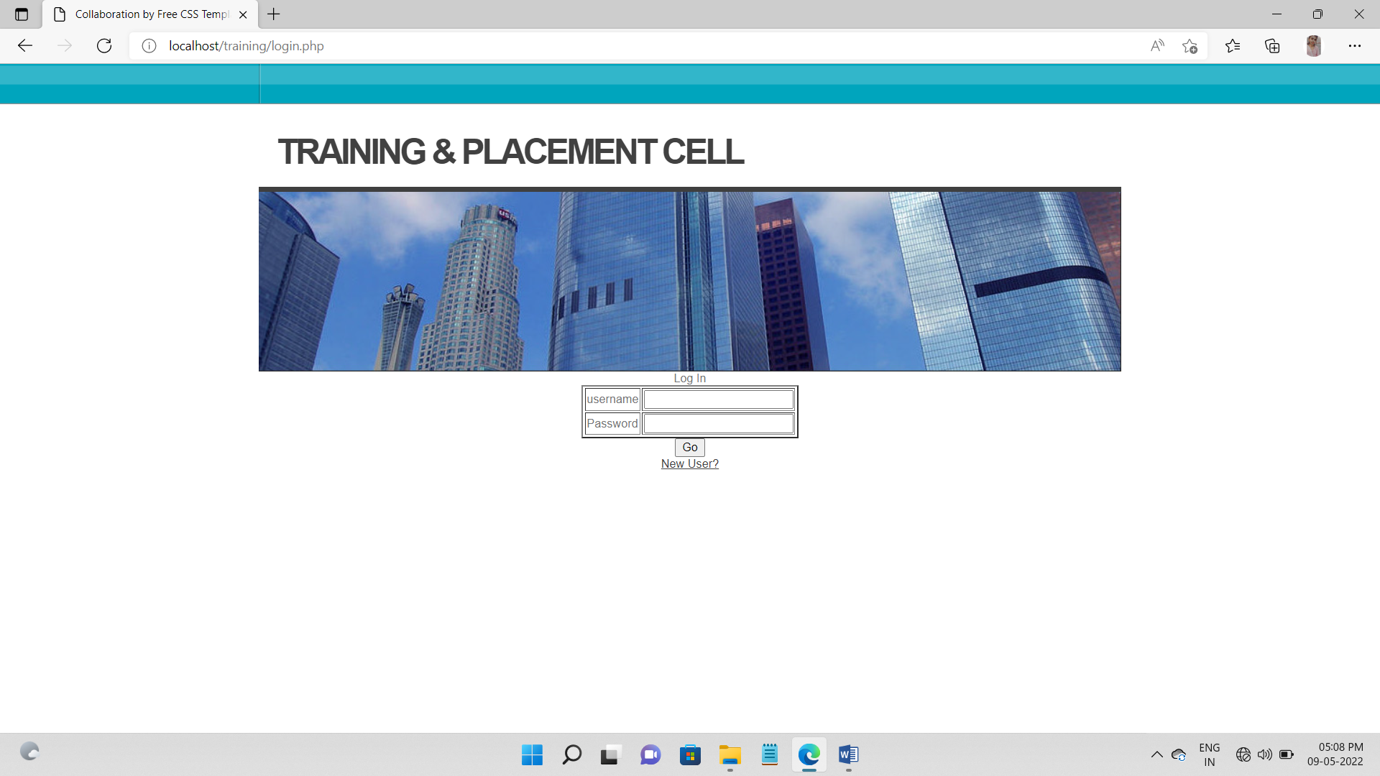

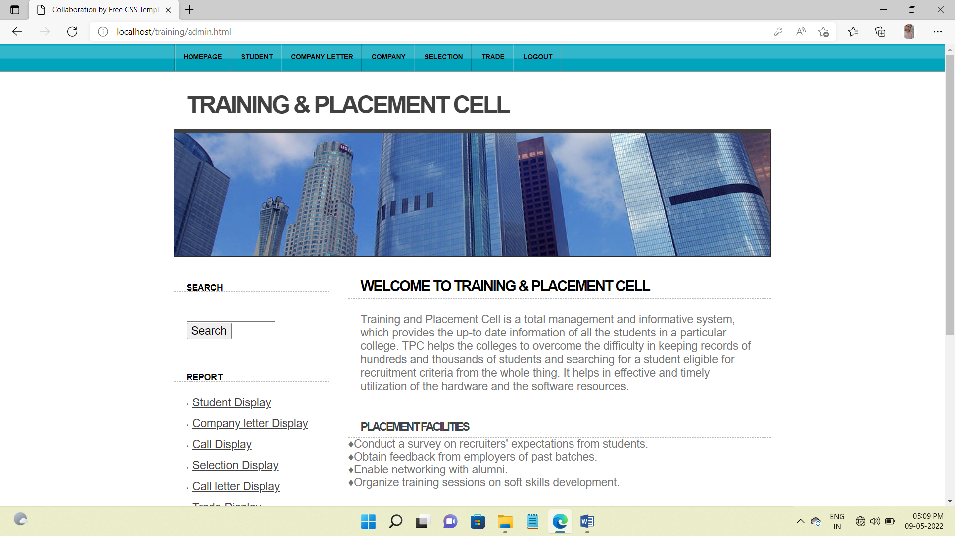

**COMPANY_FORM**

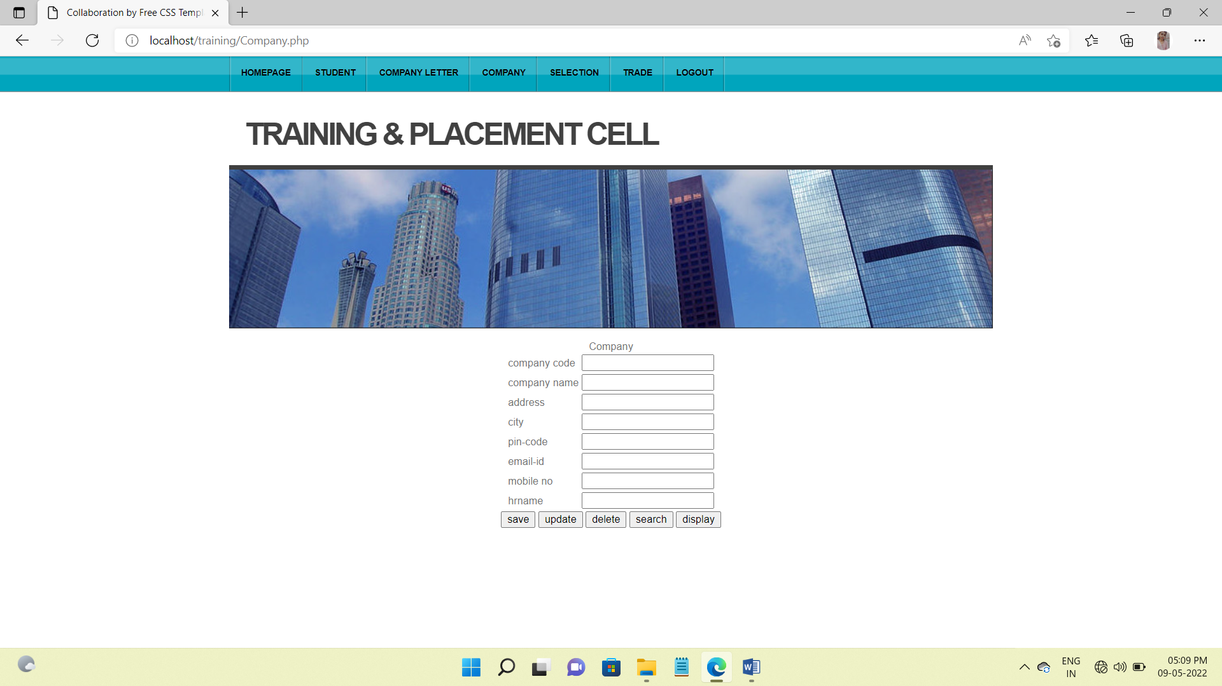

**COMPANY_LETTER_FORM**

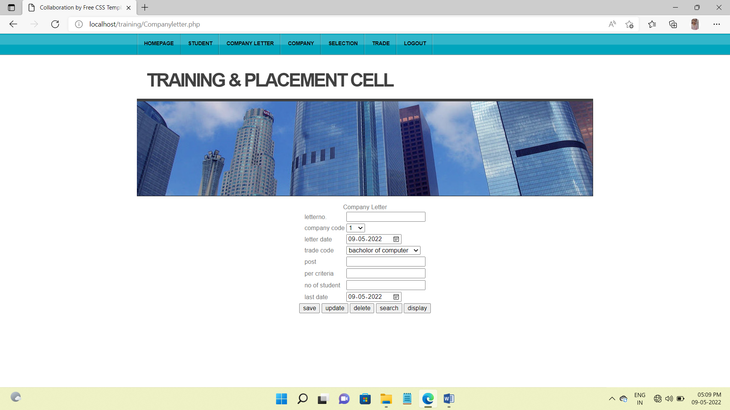

**STUDENT_FORM**

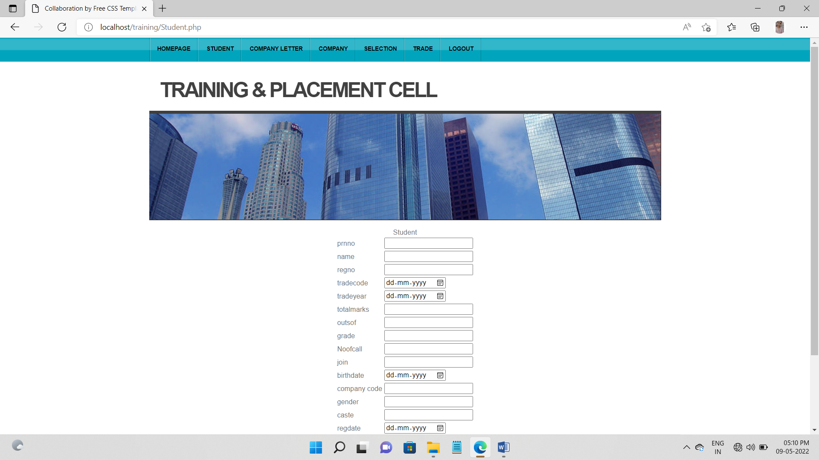

**SELECTION_FORM**

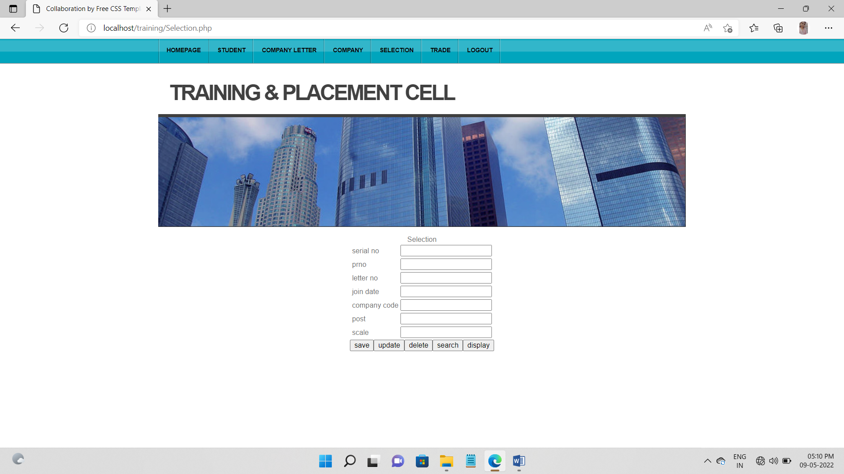

**TRADE_FORM**

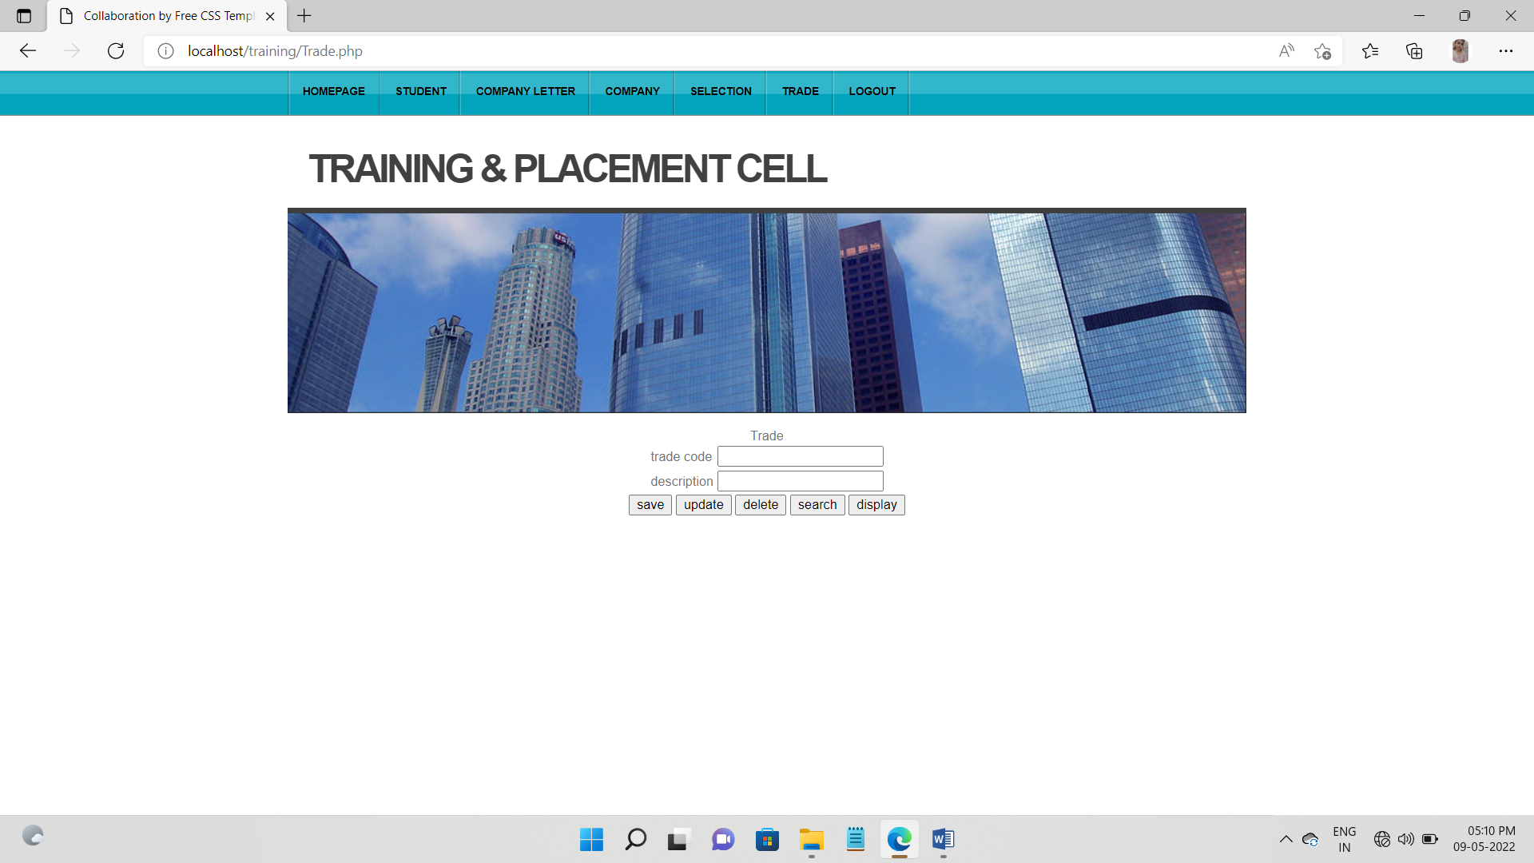

* **SAMPLE OUTPUT DESIGNS**

**STUDENT_REPORT**

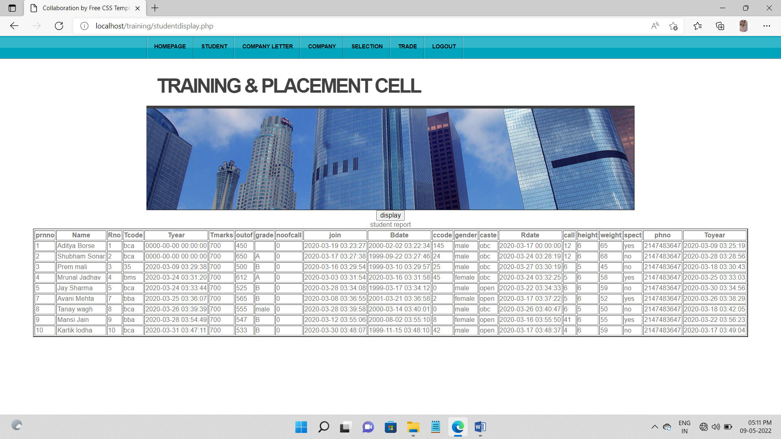

**COMPANY_LETTER_REPORT**

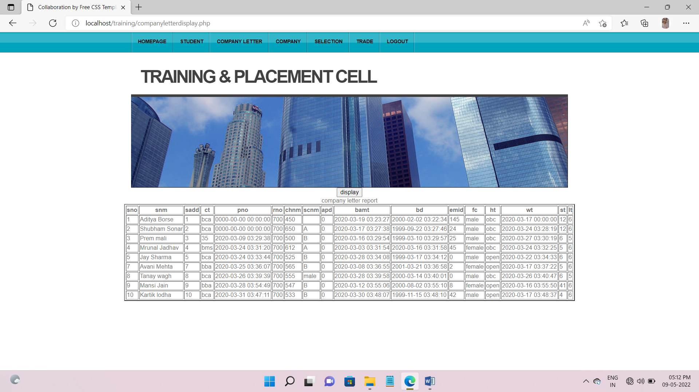

**TRADE_REPORT**

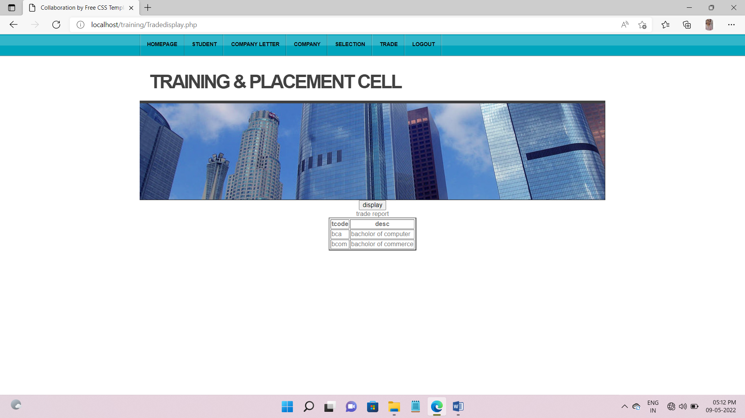

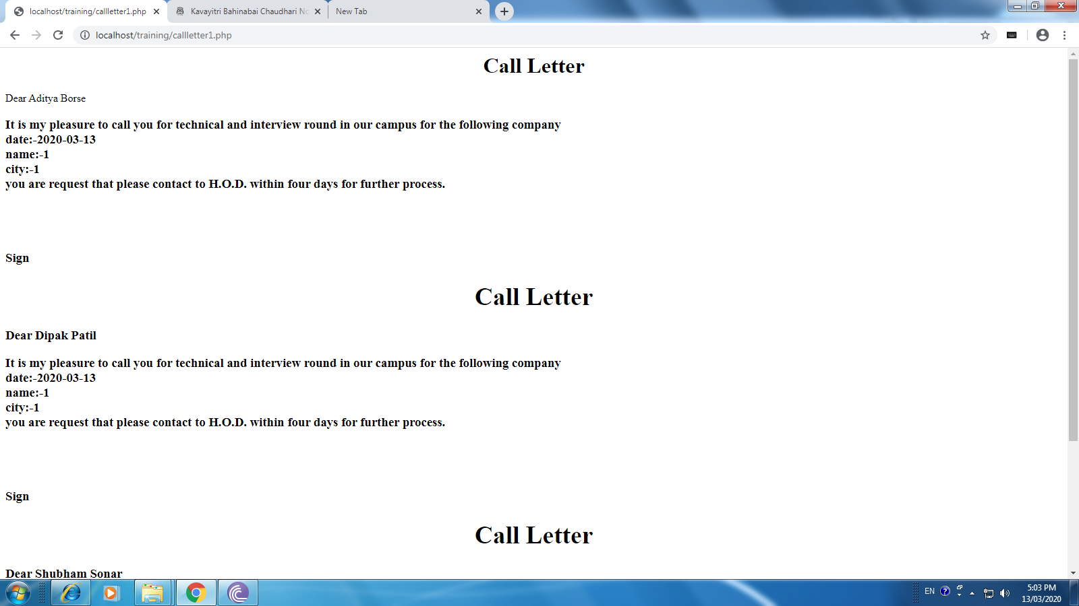

**CHAPTER 11**

**TESTING AND DEBUGGING**:-

**TESTING –**

Once code has been generated, the system testing begins.

**OBJECTIVES –**

* Testing is a procedure of executing a program with the intent of finding an error.
* A successful test is one that uncovers an as yet undiscovered error.
* To ensure that during operations input, processing and output are detected and corrected.

**DEBUGGING –**

Debugging is the process that results in the removal of an error. Once bug has been found, it must be corrected.

**OUTCOMES –**

* + - 1. Cause will be found and corrected.
      2. Cause will not be found.

**WHITE BOX TESTING –**

White Box Testing is sometimes called glass-box testing focuses on the program control structure of the procedural design. To ensure that all statements in the program have been executed at least once and all logical conditions have been exercised.

I have tested each module individually whey they were developed.

**TEST CASES –**

**MODULE NAME: form login**

* A user cannot access the purchase and sales management system unless and until he enters the valid user name and password.

**MODULE NAME: Customer master**

* Whenever a user enters a Customer Code, or whole-seller code which already exists, it is invalid and an error message will be displayed.

**MODULE NAME: Customer master**

* + To get different sizes of paper, the user is requested to enter valid size code. If valid size code is not entered, an error is focused.

**MODULE NAME: Paper invoice master**

* + - Here I tested whether or not valid calculations are performed. Each and every section of every module contains error-handling facility. Some of these are:-
    - Navigation Button: If user is on first record and if he clicks the ‘previous’ button, Message Box will be displayed whether to continue or not. If he clicks OK button, he will be taken to the last record and vice-versa for ‘Next’ button.
    - Add Button: Only valid data is accepted like in numeric field only number, in Date field only Date and so on. The user must click on ‘Save’ button and he is prompted whether to save or not and whether data is present in.

**PARALLEL TESTING –:**

Sets of transactions performed manually are collected and their results are compared with the results of this system. The codes where results did not match were corrected and therefore the system works effectively according to the needs and requirements of the company.

**ALPHA TESTING –:**

The alpha testing group consisted of friends, professors and those who are known to the organization.

The tests are conducted under all possible conditions and the identified bugs are removed.

There are also other testing in the system which are not defined here and many other testing can be done further as testing is an endless process

**CHAPTER 12**

**IMPLEMENTATION**

**User Training Guide**

An analysis of user training is based on two factors user capabilities and nature of the system being installed. User range from the native to the sophisticated user.

Generally sophisticated user to learn from manuals while operational user learn from demonstration and form on line help. User must read manuals but they will learn for demonstration through visual aids. User also tends to be natural teacher. For many user training is most important to take the information’s means it is necessary to provide documentation that user will read and refer to over the file of system. An important document that can be provided is introduction of the system and the sheets instruct the user and how to start the system about the various functions that contain description of each menu.

Another users training element is a training demonstration, live demonstration with personal contacts are externally effective for training user. In demonstration a new concept that is known in many ways (see it, do it) so quickly learned. It is most important that at the time of demonstration the user receive encouragement and attention.

Hearing and asking question and making mistakes help on understanding the system and improve self-confidence. The three main phases in implementation take place in series; there are the initial installations the text of the system and the evaluation maintain of control of the system.

Expected Problems and Solution:-

No-body is perfect therefore you make mistake when using a computer here we discuss the few of the more common problems & how to correct them.

**1) The printer off:-**

When the printer is off the computer will indicate the printer problems & the desired report will not print, simply turn the printer on & return.

**2) File not Found:-**

The only way this can happen if we forget to place telephone fault. System files in particular directory of proper drive, simply check and place disk in correct drive to avoid this mistake.

**3) Lost the Last Data Enter:-**

As in any other computer, programmer of telecom system open its, files to be read, record information etc., or any unauthorized user deletes the record of files then to avoid these problem when we return to the dos form main we should take the backup of all data files.

**CHAPTER 13**

**MERITS, DEMERITS AND ADVANTAGES**

**EXISTING SYSTEM AND ITS DEMERITS**

The earlier system is not computerized. All transactions in the system are done manually maintaining records. To make this laborious job simple the clients have to computerize the system. The management and all the departments that have been carrying out this job using manually makes the job more complicated and tedious most of the times. So, the best way is computerize computerization of the current environment.

For example, in the earlier system placement officer has to collect student details for placements. Approving those student details takes lot of time. Placement officer and students have to consult each other directly if any information is needed. If any new company come for placements, placement officer and his staff has to search the student details and they have to find the eligible candidates for that particular company placement.

Here searching for eligible candidates takes lots of time. And sometimes some candidates’ details may be missed.

**DEMERITS OF EXISTING SYSTEM**

* It takes so much time for a placement officer to collect students’ details and approving the details provided by them.
* Poor communication between students and placement officer, so here intimating about new placements is a hard task.
* Students may not know about company details. Here also poor communication provides a problem.
* Candidate may not get required information if concerned TPO is   not   at the desk.

**EXISTING SYSTEM AND ITS MERITS**

The proposed system is fully computerized, which removes all the drawbacks of existing system. Proposed system is an online application that can be accessed throughout the organization and outside as well with proper login provided. This system can be used as an application for the TPO of the college to manage the student information with regards to placement. Students logging should be able to upload their information in the form of a CV.

The home page contain various links such as links to login ,various services like events happened, achievements and recruiter details etc., .The administrator will create the users and the users will use the accounts created by administrator. When the user entered into his respective page he has to update his details. And the details are to be approved by the administrator.

All the users have some common services like changing password, updating details, searching for details, checking the details, mailing to administrator, and reading the material uploaded by admin if the user is a student. Administrator has to do the services like adding events, achievements and he can reply to the mails sent by users. He can upload materials, search for student details, and he has the right to approve the students.

**ADVANTAGES OF THE PROPOSED SYSTEM**

* Placement officer can easily collect student’ details, and approve the details provided by them.
* As it is an online application, communication with placement officer is easy to students and recruiters, so here intimating about new placements very easy task.
* Students can know about company details through the details provided by Placement officer and through the websites provided by him at *recruiters’* option.
* Here recruiters can also search for the details provided by students on the basis of their percentage.
* Placement officer can send required materials used for placements preparation to students. With this option preparation for placements becomes easy.

**PROJECT MODULES**

There are mainly 3 modules in the project “Training and Placement Cell” They are:

1. Student module.
2. Administrator module.
3. Recruiter module.

**Ø  Student module consists of services like:**

* Update details: This service provides the user to update their details.
* Check details: This service provides the user to check his details.
* Material: This service provides the user to check for materials uploaded by administrator
* Mailing: This service provides the user to mail to administrator.
* Change password: This service enables the users to change password

**Ø  Administrator module consists of services like:**

* Update details: Allows administrator to update his (college) details.
* Update statistics: Allows administrator to insert/update statistics like no. Of students selected etc.
* Add student: Allows administrator to add a student to database.
* Add recruiter: Allows administrator to add a recruiter to database.
* Add event: Allows administrator to add/insert an event.
* Approve: Allows administrator to verify the details of the student, and to approve him to the application if they are correct.
* Student details: Allows administrator to search for student information According to eligibility criteria for recruitment process.
* Upload material: Allows administrator to upload material for students.
* Mailing: Allows administrator to reply for the mails sent by users.
* Change password: This service enables the administrator to change password.

**Ø  Recruiter module consists of services like:**

* Update details: This service provides the user to update their details.
* College details: This service provides the user to check the college details.
* Student details: This service allows recruiter to search for student information according to eligibility criteria for recruitment process.
* Mailing: This service provides the user to mail to administrator.
* Change password: This service enables the users to change password.